Project Design Phase-II
Data Flow Diagram & User Stories

Date | 31 January 2026
Team ID | LTVIP2026TMIDS28502
Project Name | Visualizing Housing Market Trends: An Analysis of Sale Prices and Features using Tableau
Maximum Marks | 4 Marks

Data Flow Diagrams:
The DFD shows how data enters the system as a CSV dataset, how Tableau Desktop processes the data to generate visualizations, and how dashboards are published to Tableau Public for user access.
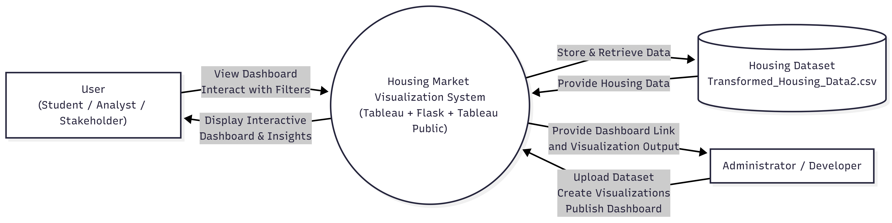
User Stories
Use the below template to list all the user stories for the product.
User Type | Functional Requirement (Epic) | User Story Number | User Story / Task | Acceptance Criteria | Priority | Release
Student / Data Analyst | Dataset Loading | USN-1 | As a user, I can load the housing dataset into Tableau Desktop for analysis | Dataset is successfully loaded and visible in Tableau | High | Sprint-1
Student / Data Analyst | Data Visualization | USN-2 | As a user, I can create visualizations such as charts and KPI indicators using Tableau | Visualizations are created and display correct data | High | Sprint-1
Student / Data Analyst | Dashboard Creation | USN-3 | As a user, I can create an interactive dashboard combining multiple visualizations | Dashboard displays all visualizations correctly | High | Sprint-1
Student / Data Analyst | Story Creation | USN-4 | As a user, I can create a Tableau Story to present insights step-by-step | Story is created and shows visualizations in sequence | Medium | Sprint-1
Student / Data Analyst | Dashboard Publishing | USN-5 | As a user, I can publish the dashboard to Tableau Public | Dashboard is accessible via public link | High | Sprint-1
Web User / Stakeholder | Dashboard Viewing | USN-6 | As a user, I can view the housing market dashboard through a web browser | Dashboard loads and displays correctly | High | Sprint-1
Web User / Stakeholder | Dashboard Interaction | USN-7 | As a user, I can interact with dashboard filters and visualizations | Filters and visualizations respond correctly | Medium | Sprint-1
Administrator / Developer | Web Integration | USN-8 | As a developer, I can integrate the Tableau dashboard into a Flask web application | Dashboard is embedded and accessible via web interface | High | Sprint-2
Administrator / Developer | Dashboard Update | USN-9 | As a developer, I can update dataset and republish dashboard when needed | Updated dashboard reflects new data | Medium | Sprint-2

